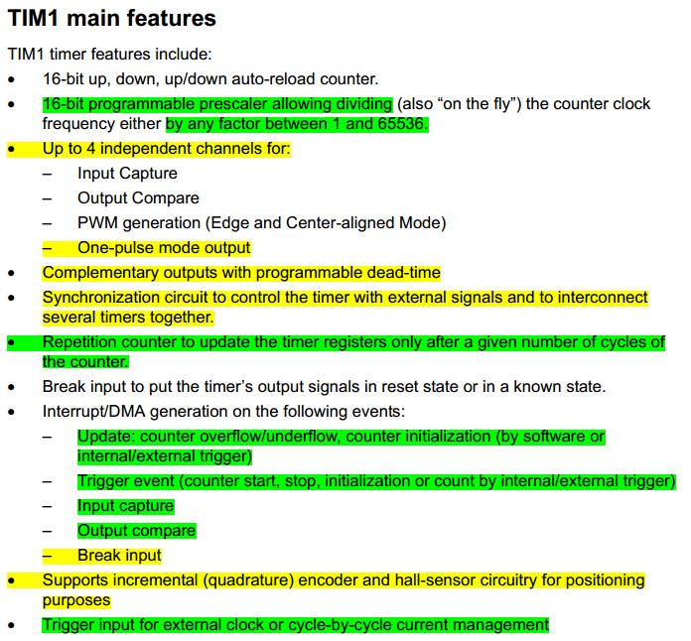
TIM 1
Main features Description:
- The counter can count up, down or both up and down.
- The counter, the auto-reload register and the prescaler register can be written or read by
software This is true even when the counter is running.

The counter is clocked by the prescaler output CK_CNT, which is enabled only when the
counter enable bit (CEN) in TIMx_CR1 register is set.

Note that the counter starts counting 1 clock cycle after setting the CEN bit in the TIMx_CR1 register.

Counter Modes:
1- Upcounting mode:
In up-counting mode, the counter counts from 0 to the auto-reload value (content of the TIMx_ARR register), then restarts from 0 and generates a counter overflow event.
If the repetition counter is used, the update event (UEV) is generated after up-counting is repeated for the number of times programmed in the repetition counter register (TIMx_RCR). Else the update event is generated at each counter overflow.

1- Downcounting mode:
In downcounting mode, the counter counts from the auto-reload value (content of the TIMx_ARR register) down to 0, then restarts from the auto-reload value and generates a counter underflow event.
If the repetition counter is used, the update event (UEV) is generated after downcounting is repeated for the number of times programmed in the repetition counter register plus one (TIMx_RCR+1). Else the update event is generated at each counter underflow.

3- Center-aligned mode (up/down counting):
In center-aligned mode, the counter counts from 0 to the auto-reload value (content of the TIMx_ARR register) – 1, generates a counter overflow event, then counts from the auto reload value down to 1 and generates a counter underflow event. Then it restarts counting
from 0.

Center-aligned mode is active when the CMS bits in TIMx_CR1 register are not equal to '00'.

In this mode, the DIR direction bit in the TIMx_CR1 register cannot be written. It is updated by hardware and gives the current direction of the counter.

The UEV update event can be disabled by software by setting the UDIS bit in the TIMx_CR1 register. This is to avoid updating the shadow registers while writing new values in the preload registers. Then no update event occurs until UDIS bit has been written to 0. However, the counter continues counting up and down, based on the current auto-reload value.
Repetition counter:
the update event (UEV) is generated with respect to the counter overflows or underflows. It is actually generated only when the repetition counter has reached zero.

This means that data are transferred from the preload registers to the shadow registers (TIMx_ARR auto-reload register, TIMx_PSC prescaler register, but also TIMx_CCRx capture/compare registers in compare mode) every N+1 counter overflows or underflows, where N is the value in the TIMx_RCR repetition counter register.

Clock selection:
The counter clock can be provided by the following clock sources:
• Internal clock (CK_INT).
• External clock mode1: external input pin.
• External clock mode2: external trigger input ETR.
• Internal trigger inputs (ITRx): using one timer as prescaler for another timer.

